Greensburg tracts: the big one is 8038
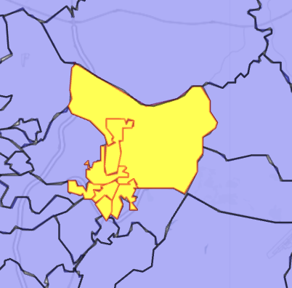
A neighboring nameless tract has 8045.02,
but other 8045's:
tt1.sw[grep('8045', tt1.sw$tracts), ]
Simple feature collection with 2 features and 11 fields
Geometry type: MULTIPOLYGON
Dimension: XY
Bounding box: xmin: -79.57241 ymin: 40.22286 xmax: -79.50753 ymax: 40.28285
Geodetic CRS: NAD83
tracts places towns county.tracts tracts.short lat.tracts
591 42129804501 Youngwood Youngwood 129 8045.01 +40.2550632
591.1 42129804501 South Greensburg South Greensburg 129 8045.01 +40.2550632
lon.tracts lat.places lon.places geometry tract_count
591 -079.5425163 +40.2443238 -079.5807121 MULTIPOLYGON (((-79.57241 4... 2
591.1 -079.5425163 +40.2781983 -079.5474351 MULTIPOLYGON (((-79.57241 4... 2
place_count
591 3
591.1 3
> tt1.sw[grep('8044', tt1.sw$tracts), ]
Simple feature collection with 2 features and 11 fields
Geometry type: MULTIPOLYGON
Dimension: XY
Bounding box: xmin: -79.55808 ymin: 40.27019 xmax: -79.53745 ymax: 40.28702
Geodetic CRS: NAD83
tracts places towns county.tracts tracts.short
2608 42129804400 South Greensburg South Greensburg 129 8044
2608.1 42129804400 Southwest Greensburg Southwest Greensburg 129 8044
lat.tracts lon.tracts lat.places lon.places geometry
2608 +40.2781983 -079.5474351 +40.2781983 -079.5474351 MULTIPOLYGON (((-79.55808 4...
2608.1 +40.2781983 -079.5474351 +40.2918690 -079.5478131 MULTIPOLYGON (((-79.55808 4...
tract_count place_count
2608 2 3
2608.1 2 4

